**Consolidation Days**

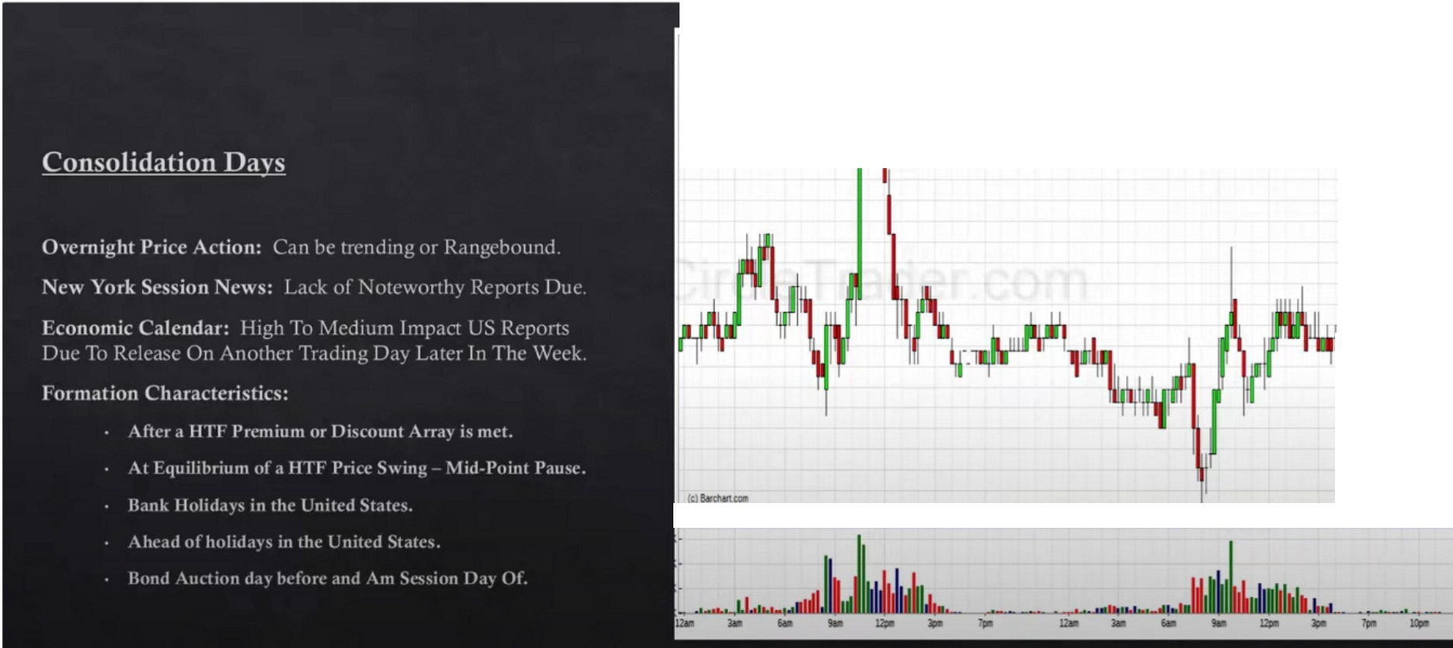

* "-'IS'4& t.JS,142

llfl1J11:::

-j :::

*·""1*

·W-»

-'5>

•ISl-22

-w-•

-W-lt

,:-,, =-==================="'"•

Not teaching specific setups, its teaching thought process and how it influences forex

Generally what will happen is profit taking so price will pause at a HTF premium array when bullish, knowing this will help us also in the forex market and all the intermarket analysis

It can stay at HTF EQ for a while, even when it retraces back to EQ dont expect an immediate reaction

Think about what causes consolidation in the bond market, we will have a gameplan and we can incoorporate these ideas in our trading

The incoorporation of the interest rates and bond market is the missing link, if were going to see consolidation in the bond market we can expect the other markets to see some kind of consolidation as well

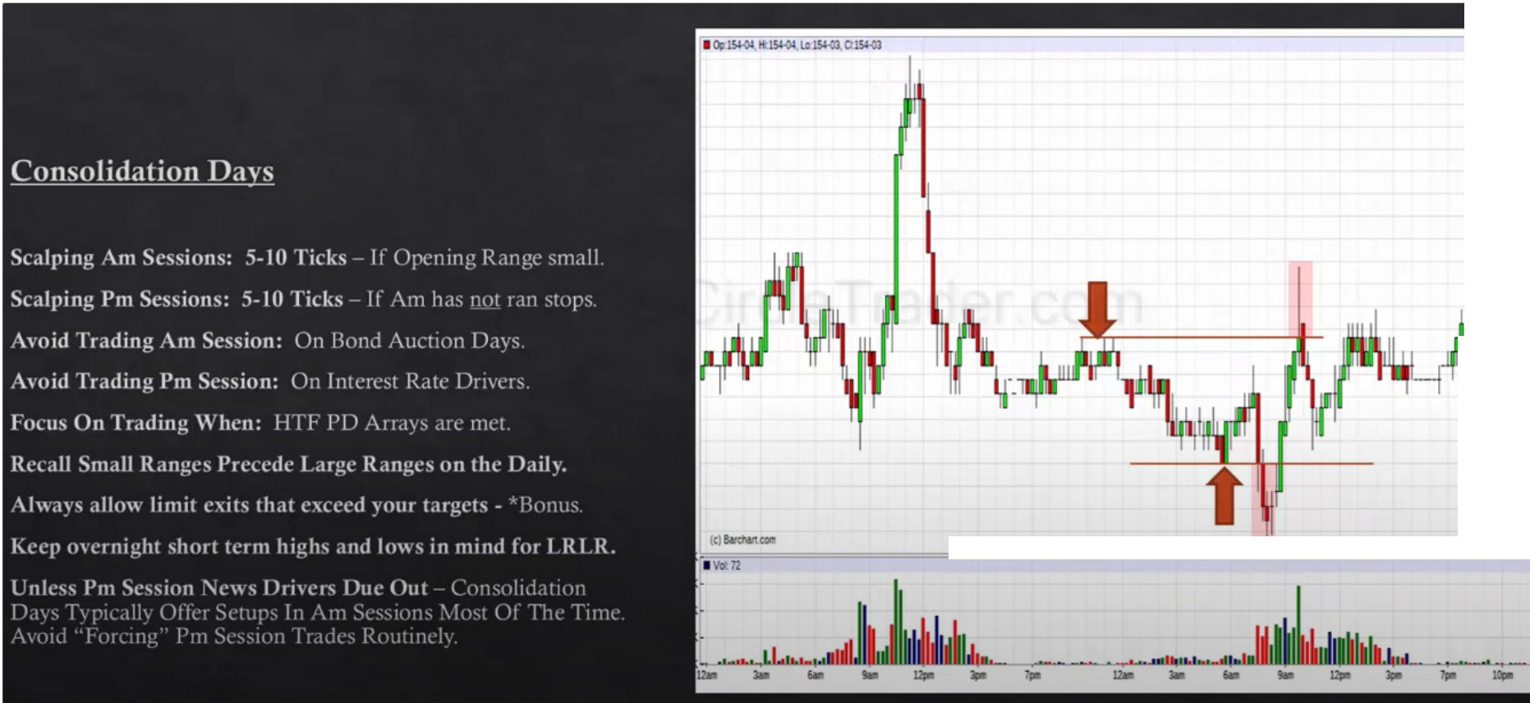

.1.15.1.-.Z2

.-1.5.1.-1.9

.....

•151-1&

....u

....u

-•15-'-10

l**l1J1I** .**·**,**m**...,

--

**·""6**

I

.,..

·_",.".,",

.,...

.

**•1'>5**

.,..

-15),2,1

.,...

-IS>•

...,.

.

Opening range small: 12 ticks or less

Opening range small then generally we will have an expansion

It would move in the direction of pre determined institutional orderflow Only trade PM session if AM has not ran stops

When a HTF premium array is met after a long bullish move, thats when we adapt, we dont expect big expansions we expect a pause, so either move to the sidelines or operate in a scalpers

mentality

When the pause happens it allows us to study where the next move will be

Consolidation days are sign that there are big opportunities coming in the form of large range days You need to give your 100% focus on the market while scalping

LRLR: low resistance liquidity runs

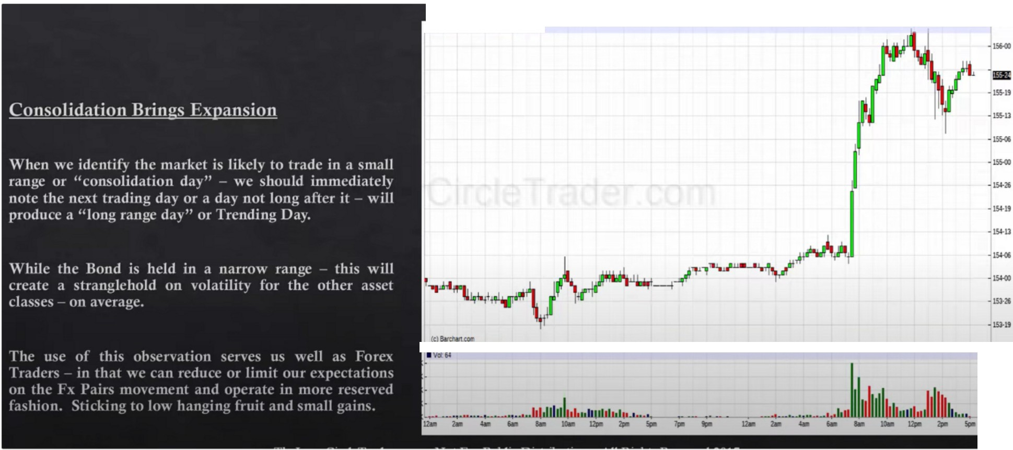

* **C.:1SHllldSi-25,Ul.155,-2lQ.155,-2J**

.s: , 15>U

How do we know a large range day is ocming and when? The economic calendar will tell us

If were going to be professional then we have to have rules and parameters, if you know that over a long period of time trading in consolidations is bad that will create a professional perspective

If you focus on the process and the parameters you wont have fear or anxiety of missing moves Great pscyhology at around 18 minutes

By having rules youll see its profatible for you monetary and psychology wise to operate in a rule based idea, by having the process of knowing what you should do when the bond market is in a consolidation it removes fear and uncertainty

Consolidation - low expectation across all asset classes

Once we leave the consolidation it tends to be a trendy enviroment, those are easy trading days

When we look at consolidation we should be happy with the opportunities that are coming, we sit back during consolidation periods. We know that smart money is setting up the next big move, the bond market speaks for every other market

Arjo I Twitter, lnstagram I Linktree

Linktree. Make your link do more.

, https://t.co/HhmmTN1fUI

JavaScript is not available.

**'I#** https://twitter.com/arjoio